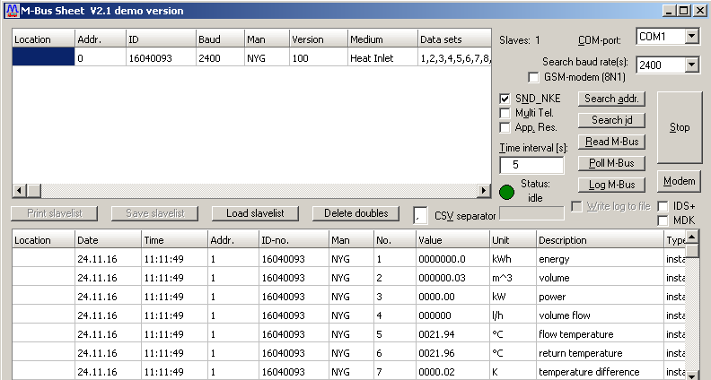
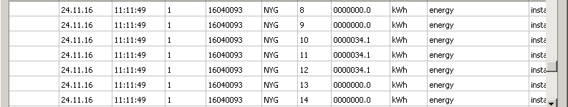
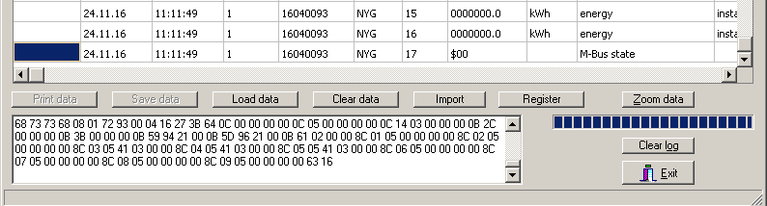

Search baud rate 2400!
Slave ID search started!
TX-buffer:
10 40 FD 3D 16
RX-buffer:
E5
TX-buffer:
10 40 FF 3F 16
RX-buffer:

0FFFFFFF
1FFFFFFF
*** Slave found at ID (secondary adress) 16040093
2FFFFFFF
3FFFFFFF
4FFFFFFF
5FFFFFFF
6FFFFFFF
7FFFFFFF
8FFFFFFF
9FFFFFFF
Slave ID search finished!
TX-buffer:
10 40 FF 3F 16
RX-buffer:

TX-buffer:
68 0B 0B 68 73 FD 52 93 00 04 16 FF FF FF FF 6B 16
RX-buffer:
E5
TX-buffer:
10 7B FD 78 16
RX-buffer:
68 73 73 68 08 01 72 93 00 04 16 27 3B 64 0C 00 00 00 00 0C 05 00 00 00 00 0C 14 03 00 00 00 0B 2C 00 00 00 0B 3B 00 00 00 0B 59 94 21 00 0B 5D 96 21 00 0B 61 02 00 00 8C 01 05 00 00 00 00 8C 02 05 00 00 00 00 8C 03 05 41 03 00 00 8C 04 05 41 03 00 00 8C 05 05 41 03 00 00 8C 06 05 00 00 00 00 8C 07 05 00 00 00 00 8C 08 05 00 00 00 00 8C 09 05 00 00 00 00 63 16

