1. **Вначале настраиваем порт 50000 в Лэрсе, затем запускаем ТСР.**

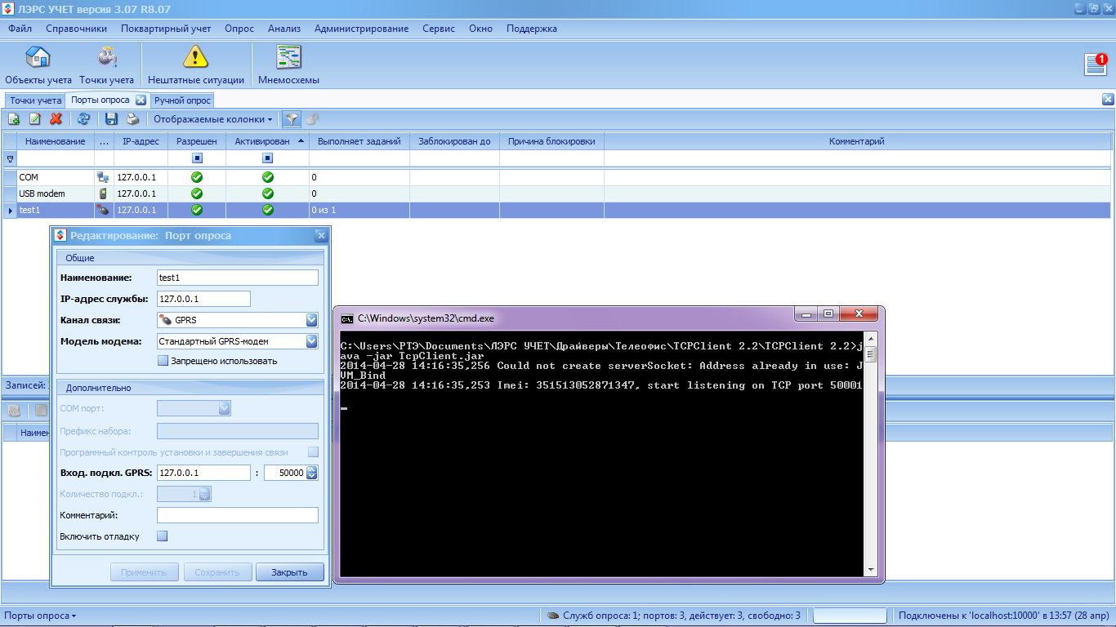

1. **Останавливаем ТСР, настраиваем в ЛЭРС порт 50001, запускаем ТСР.**

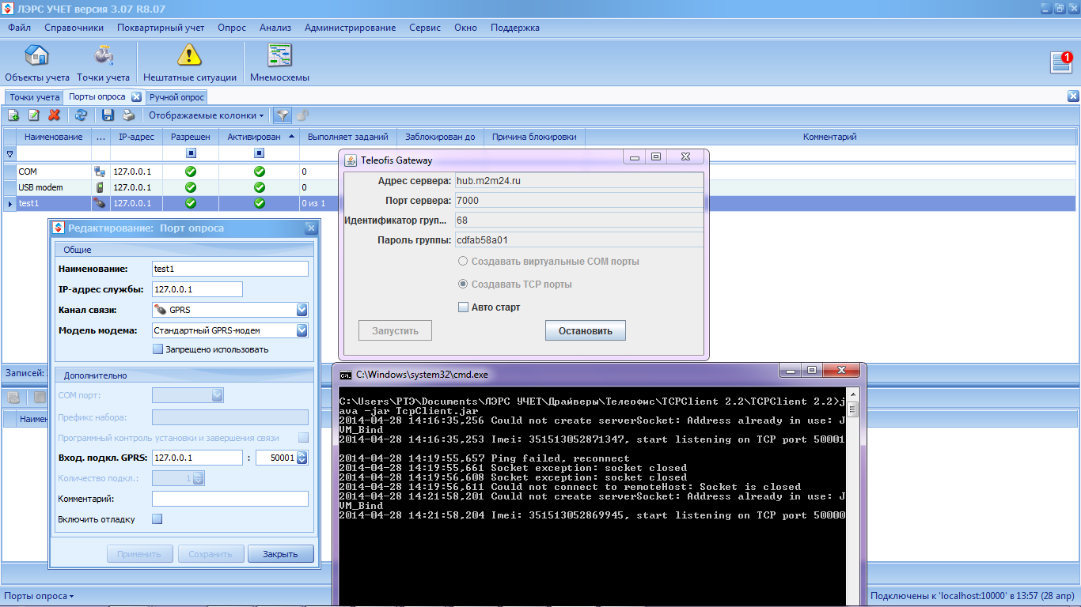

1. **Запускаем ТСР, затем настраиваем порт 50000, он не активируется службой опроса.**

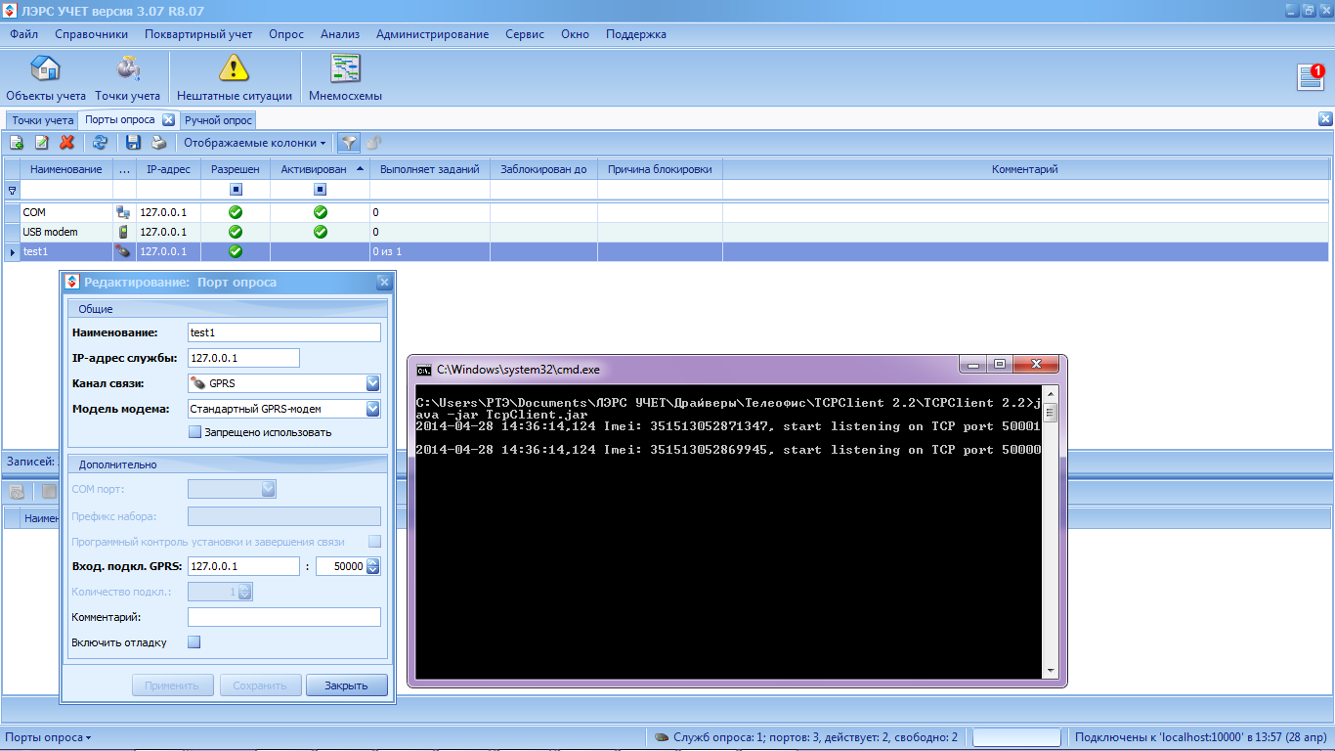

1. **Запускаем netstat**

C:\Users\РТЭ>

C:\Users\РТЭ>netstat -b

Запрошенная операция требует повышения.

**При запущенном ТСР клиенте**

Microsoft Windows [Version 6.1.7601]

(c) Корпорация Майкрософт (Microsoft Corp.), 2009. Все права защищены.

C:\Users\РТЭ>netstat -a

Активные подключения

Имя Локальный адрес Внешний адрес Состояние

TCP 0.0.0.0:80 RTE-PC:0 LISTENING

TCP 0.0.0.0:135 RTE-PC:0 LISTENING

TCP 0.0.0.0:443 RTE-PC:0 LISTENING

TCP 0.0.0.0:445 RTE-PC:0 LISTENING

TCP 0.0.0.0:554 RTE-PC:0 LISTENING

TCP 0.0.0.0:2869 RTE-PC:0 LISTENING

TCP 0.0.0.0:5060 RTE-PC:0 LISTENING

TCP 0.0.0.0:5357 RTE-PC:0 LISTENING

TCP 0.0.0.0:10000 RTE-PC:0 LISTENING

TCP 0.0.0.0:10243 RTE-PC:0 LISTENING

TCP 0.0.0.0:26143 RTE-PC:0 LISTENING

TCP 0.0.0.0:49152 RTE-PC:0 LISTENING

TCP 0.0.0.0:49153 RTE-PC:0 LISTENING

TCP 0.0.0.0:49154 RTE-PC:0 LISTENING

TCP 0.0.0.0:49155 RTE-PC:0 LISTENING

TCP 0.0.0.0:49159 RTE-PC:0 LISTENING

TCP 0.0.0.0:49167 RTE-PC:0 LISTENING

TCP 0.0.0.0:50000 RTE-PC:0 LISTENING

TCP 0.0.0.0:50001 RTE-PC:0 LISTENING

TCP 0.0.0.0:50002 RTE-PC:0 LISTENING

TCP 0.0.0.0:63303 RTE-PC:0 LISTENING

TCP 127.0.0.1:10000 RTE-PC:49162 ESTABLISHED

TCP 127.0.0.1:10000 RTE-PC:51006 ESTABLISHED

TCP 127.0.0.1:49162 RTE-PC:10000 ESTABLISHED

TCP 127.0.0.1:49458 RTE-PC:49459 ESTABLISHED

TCP 127.0.0.1:49459 RTE-PC:49458 ESTABLISHED

TCP 127.0.0.1:51006 RTE-PC:10000 ESTABLISHED

TCP 192.168.0.150:139 RTE-PC:0 LISTENING

TCP 192.168.0.150:49171 213.199.179.140:40031 ESTABLISHED

TCP 192.168.0.150:49176 91.190.218.53:12350 ESTABLISHED

TCP 192.168.0.150:49180 bn1msgr2011109:https ESTABLISHED

TCP 192.168.0.150:49397 garamond:5222 ESTABLISHED

TCP 192.168.0.150:49398 garamond:5222 ESTABLISHED

TCP 192.168.0.150:49399 bos-p043b-rdr1:5190 ESTABLISHED

TCP 192.168.0.150:51278 mrim101:2042 ESTABLISHED

TCP 192.168.0.150:51767 li268-203:7000 ESTABLISHED

TCP 192.168.0.150:51807 e:https ESTABLISHED

TCP 192.168.0.150:52073 jim29:https ESTABLISHED

TCP 192.168.0.150:52086 e:https SYN_SENT

TCP 192.168.0.150:52087 e:https ESTABLISHED

TCP 192.168.0.150:52089 jim14:https ESTABLISHED

TCP 192.168.0.150:52090 oktopus3:https SYN_SENT

TCP 192.168.0.150:52091 oktopus1:https ESTABLISHED

TCP 192.168.0.150:52092 oktopus1:https SYN_SENT

TCP 192.168.0.150:52093 oktopus1:https ESTABLISHED

TCP 192.168.0.150:52094 e:https SYN_SENT

TCP 192.168.0.150:52095 e:https SYN_SENT

TCP 192.168.0.150:52096 e:https SYN_SENT

TCP 192.168.0.150:52097 e:https SYN_SENT

TCP 192.168.0.150:63303 194-146:54889 ESTABLISHED

TCP 192.168.0.150:63303 dsl-85-172-115-98:50967 ESTABLISHED

TCP 192.168.0.150:63303 Samson:63134 TIME_WAIT

TCP 192.168.0.150:63303 Samson:63218 ESTABLISHED

TCP 192.168.0.150:63303 Samson:63236 ESTABLISHED

TCP 192.168.0.150:63303 91.215.190.136:35922 ESTABLISHED

TCP 192.168.0.150:63303 host-94-255-32-194:19889 ESTABLISHED

TCP 192.168.0.150:63303 128-70-120-15:61461 ESTABLISHED

TCP [::]:80 RTE-PC:0 LISTENING

TCP [::]:135 RTE-PC:0 LISTENING

TCP [::]:445 RTE-PC:0 LISTENING

TCP [::]:554 RTE-PC:0 LISTENING

TCP [::]:2869 RTE-PC:0 LISTENING

TCP [::]:5357 RTE-PC:0 LISTENING

TCP [::]:10243 RTE-PC:0 LISTENING

TCP [::]:26143 RTE-PC:0 LISTENING

TCP [::]:49152 RTE-PC:0 LISTENING

TCP [::]:49153 RTE-PC:0 LISTENING

TCP [::]:49154 RTE-PC:0 LISTENING

TCP [::]:49155 RTE-PC:0 LISTENING

TCP [::]:49159 RTE-PC:0 LISTENING

TCP [::]:49167 RTE-PC:0 LISTENING

TCP [::]:50000 RTE-PC:0 LISTENING

TCP [::]:50001 RTE-PC:0 LISTENING

**При остановленном ТСР клиенте**

C:\Users\РТЭ>netstat -a

Активные подключения

Имя Локальный адрес Внешний адрес Состояние

TCP 0.0.0.0:80 RTE-PC:0 LISTENING

TCP 0.0.0.0:135 RTE-PC:0 LISTENING

TCP 0.0.0.0:443 RTE-PC:0 LISTENING

TCP 0.0.0.0:445 RTE-PC:0 LISTENING

TCP 0.0.0.0:554 RTE-PC:0 LISTENING

TCP 0.0.0.0:2869 RTE-PC:0 LISTENING

TCP 0.0.0.0:5060 RTE-PC:0 LISTENING

TCP 0.0.0.0:5357 RTE-PC:0 LISTENING

TCP 0.0.0.0:10000 RTE-PC:0 LISTENING

TCP 0.0.0.0:10243 RTE-PC:0 LISTENING

TCP 0.0.0.0:26143 RTE-PC:0 LISTENING

TCP 0.0.0.0:49152 RTE-PC:0 LISTENING

TCP 0.0.0.0:49153 RTE-PC:0 LISTENING

TCP 0.0.0.0:49154 RTE-PC:0 LISTENING

TCP 0.0.0.0:49155 RTE-PC:0 LISTENING

TCP 0.0.0.0:49159 RTE-PC:0 LISTENING

TCP 0.0.0.0:49167 RTE-PC:0 LISTENING

TCP 0.0.0.0:50002 RTE-PC:0 LISTENING

TCP 0.0.0.0:63303 RTE-PC:0 LISTENING

TCP 127.0.0.1:10000 RTE-PC:49162 ESTABLISHED

TCP 127.0.0.1:10000 RTE-PC:51006 ESTABLISHED

TCP 127.0.0.1:49162 RTE-PC:10000 ESTABLISHED

TCP 127.0.0.1:49458 RTE-PC:49459 ESTABLISHED

TCP 127.0.0.1:49459 RTE-PC:49458 ESTABLISHED

TCP 127.0.0.1:51006 RTE-PC:10000 ESTABLISHED

TCP 192.168.0.150:139 RTE-PC:0 LISTENING

TCP 192.168.0.150:49171 213.199.179.140:40031 ESTABLISHED

TCP 192.168.0.150:49176 91.190.218.53:12350 ESTABLISHED

TCP 192.168.0.150:49180 bn1msgr2011109:https ESTABLISHED

TCP 192.168.0.150:49397 garamond:5222 ESTABLISHED

TCP 192.168.0.150:49398 garamond:5222 ESTABLISHED

TCP 192.168.0.150:49399 bos-p043b-rdr1:5190 ESTABLISHED

TCP 192.168.0.150:50392 SECR-WS:microsoft-ds ESTABLISHED

TCP 192.168.0.150:51278 mrim101:2042 ESTABLISHED

TCP 192.168.0.150:51300 li268-203:7000 TIME_WAIT

TCP 192.168.0.150:51337 e:https ESTABLISHED

TCP 192.168.0.150:51418 ip94:https ESTABLISHED

TCP 192.168.0.150:51429 oktopus2:https ESTABLISHED

TCP 192.168.0.150:51467 jim14:https ESTABLISHED

TCP 192.168.0.150:51474 jim29:https ESTABLISHED

TCP 192.168.0.150:51481 e:https SYN_SENT

TCP 192.168.0.150:51482 e:https SYN_SENT

TCP 192.168.0.150:51483 SECR-WS:http SYN_SENT

TCP 192.168.0.150:51484 e:https SYN_SENT

TCP 192.168.0.150:51485 e:https SYN_SENT

TCP 192.168.0.150:51486 oktopus2:https SYN_SENT

TCP 192.168.0.150:51487 oktopus3:https SYN_SENT

TCP 192.168.0.150:63303 nat:56388 TIME_WAIT

TCP 192.168.0.150:63303 dsl-85-172-115-98:50852 TIME_WAIT

TCP 192.168.0.150:63303 Samson:62359 TIME_WAIT

TCP 192.168.0.150:63303 Samson:62453 ESTABLISHED

TCP 192.168.0.150:63303 95-54-49-185:58769 TIME_WAIT

TCP 192.168.0.150:63303 isg-brass2-212-124-6-115:2373 TIME_WAIT

TCP 192.168.0.150:63303 mx1:16706 TIME_WAIT

TCP [::]:80 RTE-PC:0 LISTENING

TCP [::]:135 RTE-PC:0 LISTENING

TCP [::]:445 RTE-PC:0 LISTENING

TCP [::]:554 RTE-PC:0 LISTENING

TCP [::]:2869 RTE-PC:0 LISTENING

TCP [::]:5357 RTE-PC:0 LISTENING

TCP [::]:10243 RTE-PC:0 LISTENING

TCP [::]:26143 RTE-PC:0 LISTENING

TCP [::]:49152 RTE-PC:0 LISTENING

TCP [::]:49153 RTE-PC:0 LISTENING

TCP [::]:49154 RTE-PC:0 LISTENING

TCP [::]:49155 RTE-PC:0 LISTENING

TCP [::]:49159 RTE-PC:0 LISTENING

TCP [::]:49167 RTE-PC:0 LISTENING

C:\Users\РТЭ>